Exp. No: 6
Capacitance of a Parallel Plate Capacitor in Different Dielectric Media
Test case (i) Determination and plotting of capacitance of parallel plate capacitor for given area and dielectric thickness
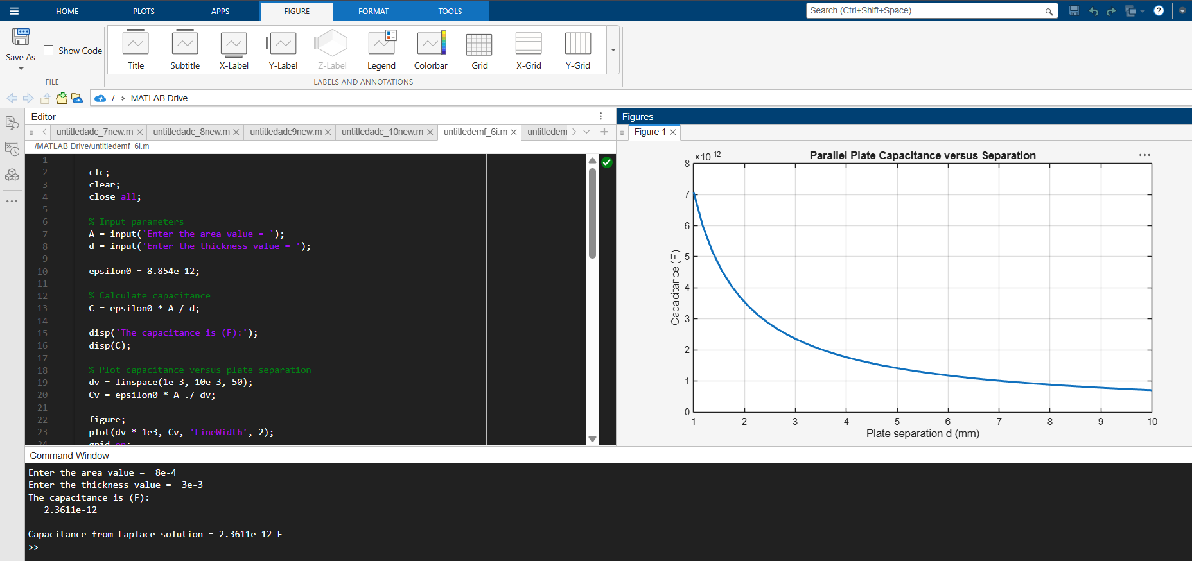
Test case (ii) Determination of capacitance of parallel plate capacitor with three different dielectric layers
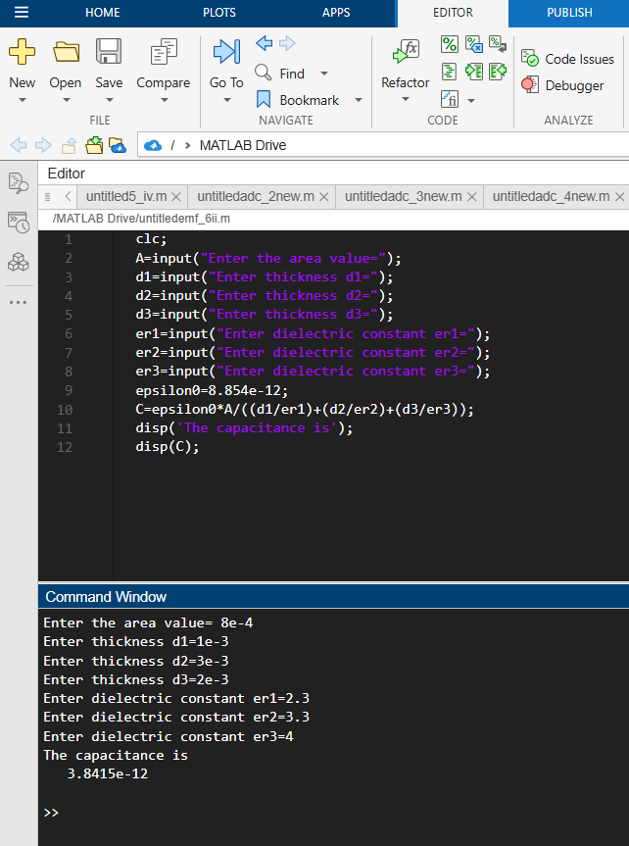
Test case (iii) Determination and plotting of capacitance variation with dielectric constant (Air)
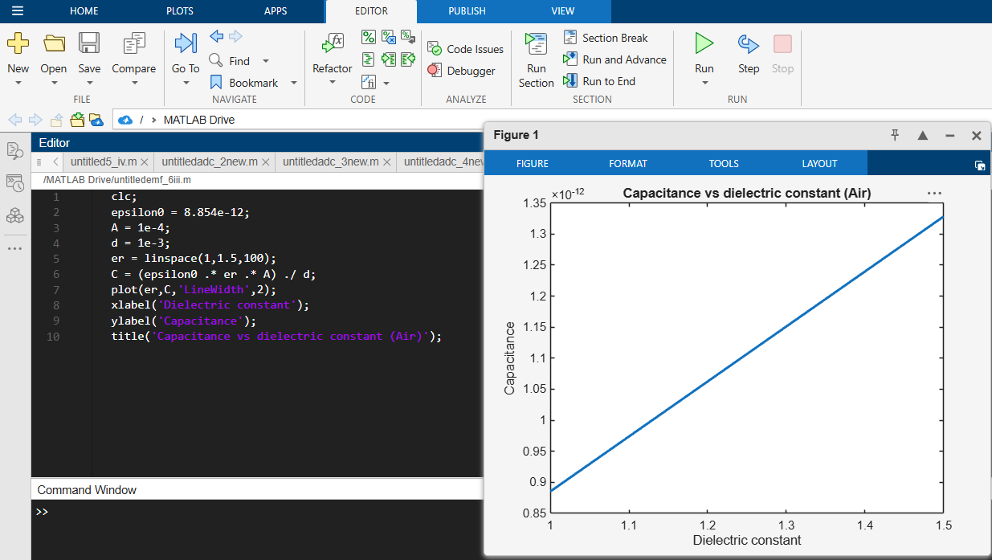
Test case (iv) Determination and plotting of capacitance variation with dielectric constant (Glass)
